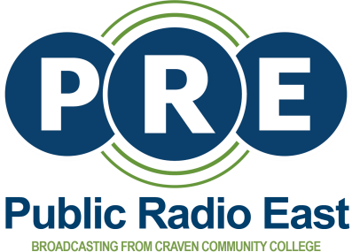

PRE News Internship Opportunity 2022

Want a career in public media? Build your portfolio at Public Radio East in New Bern, NC.

PRE is seeking a journalism student in their junior or senior year or a recent graduate to intern with us this summer.

Duties include reporting, writing and producing radio news stories; producing digital news content for our website; recording audio in the field; posting content to social media. Experience in broadcast journalism is a bonus.

Send resume, cover letter, writing and/or audio sample to info@publicradioeast.org. Deadline to apply is Friday, April 29, 2022 at 11:59 pm. Internship runs June – August 2022.

Internship is unpaid, but may be completed for college credit.

