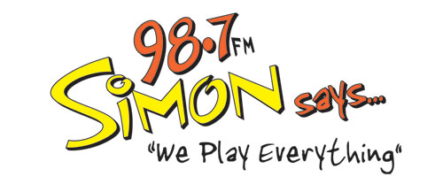

INTERNS NEEDED!
It's a glamorous job... hanging banners... riding in the truck... manning the prize wheel... getting up close and personal with Triad listeners at events and concerts…and learning all there is to know behind the scenes at one of the Triad’s top-rated radio stations!! If you have a winning attitude and an outgoing personality, WE WANT YOU to be a Simon Intern this semester!
Interested students must meet the following requirements:
You MUST be a college student with at least a 2.5 GPA and must receive credit for the internship through an accredited college/university. Preferred majors: Communications, Mass Communications, Broadcasting, Journalism, Marketing, Business, Public Relations. You must be outgoing, well-organized, driven, creative, and enjoy working in the community. An ideal candidate is preferred to have general media knowledge and basic knowledge of marketing/promotional/branding strategies. Audio production software experience is a plus! (i.e. Adobe Audition, Audacity, etc). You must have experience in MS Office products, basic website management, basic event planning, basic social media strategies, and writing press releases. You must be able to work some evenings and weekends.
To get started ASAP, send your cover letter and resume to Charley at charley@987simon.com

